HARVELELECTRIC ELECTRONIC STORE

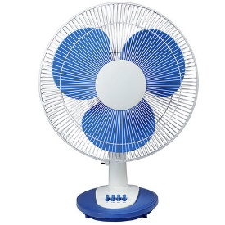

Qasa 18 Inches Rechargeable Fan QRF-5918HR

Brand: [Qasa](https://www.jumia.com.ng/qasa/)

**Price: $100**

Was ~~$150~~ 54%

+ shipping only for V.V.I.P clients.

Product details

Kindly recharge the fan immediately after purchase until the charging indicator bars stops blinking before using it. This will help prolong your battery life.  
  
No need to stay in the heat and leave the family to sweat all night till dawn. Introducing the All new Qasa QRF-5918HR 18 Inches blade size Battery rechargeable Oscillatory Fan. This fan is capable of beings used even when NEPA or your Generator fails to produce power. It can be used for 3 and a half hour at high speed or 12 hrs on a low speed running on battery.   
  
This product comes with a USB port to help with your phone charging. No need to worry. We got you covered on all front.  
  
Get inspired with the low energy sapping 33 watts electric Fan for your Home, Office or event center.  


Specifications

KEY FEATURES

* Adjustable height
* DC 12V input socket
* USB charger
* LED night light
* Rated power: 33W
* Duration time: 3.5hr/High, 12hr/Low
* Rechargeable battery: 12v 4.5Ah
* Fan size: 18''
* Fan speed: High /Middle/Low
* Remote Control Included

SPECIFICATIONS

* **SKU**: QA791HL0KTL7PNAFAMZ
* **Product Line**: QASA LTD
* **Model**: QRF-5918HR
* **Weight (kg)**: 8
* **Certifications**: Eco Friendly
* **Color**: Blue
* **Main Material**: Plastic
* **Area of Use**: Dining Room | Bedroom | Home Office | Kids Room | Nursery |Entry & Hallway
* **Features**: Rechargeable Fans